Problem Solving – level 6

1. Arrange the numbers 1 to 12 in the corners of these squares.

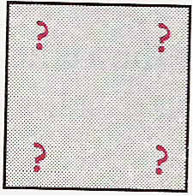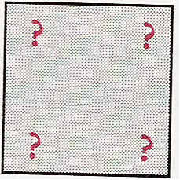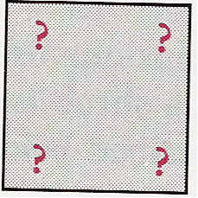

Use the following rules:

i. There must be just one number in each corner.
ii. The four numbers in each square must add to 26.

Is there more than one answer?

2. On a quiz show, Sarah earned £25 for each correct answer and lost £10 for each incorrect answer (or for questions she couldn't answer). After 20 questions had been asked, Sarah had £20. How many questions had she answered correctly?

3. When two numbers are multiplied the answer is 437. Both of these numbers are greater than 1. Find these two numbers.

4. When two numbers are multiplied the answer is 312. Find these two numbers.

Is there more than one answer? If so, find as many answers as you can.

5. In Alexandra's family each child has at least one brother and one sister. What is the smallest possible number of children in Alexandra's family?

6. Bonny counted the number of emus and elephants in a zoo. Her friend Ines counted the number of legs of these emus and elephants. Altogether Ines counted 70 legs. How many emus and how many elephants did Bonny count?

Is there more than one answer? If so, how many answers are there?

What if Ines counted 70 legs and 24 heads?

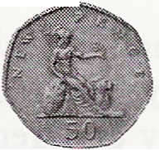
7. Philippa has £2.50 worth of coins. Some are 10p coins, some are 20p coins and the rest are 50p coins. She has twice as many 10p coins as 50p coins. She has one more 50p coin than 20p coins.
How many 50p coins does Philippa have?

